ScreenSteps Live Support Client

Table of Contents
Getting Started 3
How Do I Get Started? 3
Configure Reader Account 3
Download 3
Configure 4
Begin Browsing Content 5
How Do I Preview a Lesson? 6
How Do I Copy a Lesson URL to the Clipboard? 7
Searching 8
How Can I Limit a Search To A Manual Or Bucket? 8
Searching a Space 8
Searching Selected Bucket/Manual 9
Clipboard Templates 9
What Is A Clipboard Template? 9
How Do I Customize or Add a Clipboard Template? 11
Customizing a Template 11
Add a Template 12
Adding Login Credentials to a Clipboard Template 13
Open Preferences 13
Create a Template 14
Title Template 15
Enter Template Text 16

Getting Started

How Do I Get Started?

The ScreenSteps Live Support Client is a free desktop application for ScreenSteps Live customers. If you are not a ScreenSteps Live customer you can sign up for a free trial.

Configure Reader Account
The ScreenSteps Live Support Client uses the ScreenSteps Live API to access content. A valid username and password is required to do this. We recommend creating a reader account on ScreenSteps Live, grant the reader access to the appropriate spaces and use their username and password.

More information:
• What are Admin, Author and Reader Users?
• How do I add Readers or Groups to a Space?

Download
Next, download and install the ScreenSteps Live Support Client application.

Configure
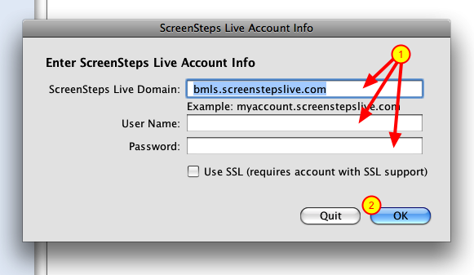
The first time you launch the application you will be prompted to enter your ScreenSteps Live domain, username and password. Enter a reader account user name and password here (1). When you have finished, click OK (2) and your settings will be verified.

Begin Browsing Content
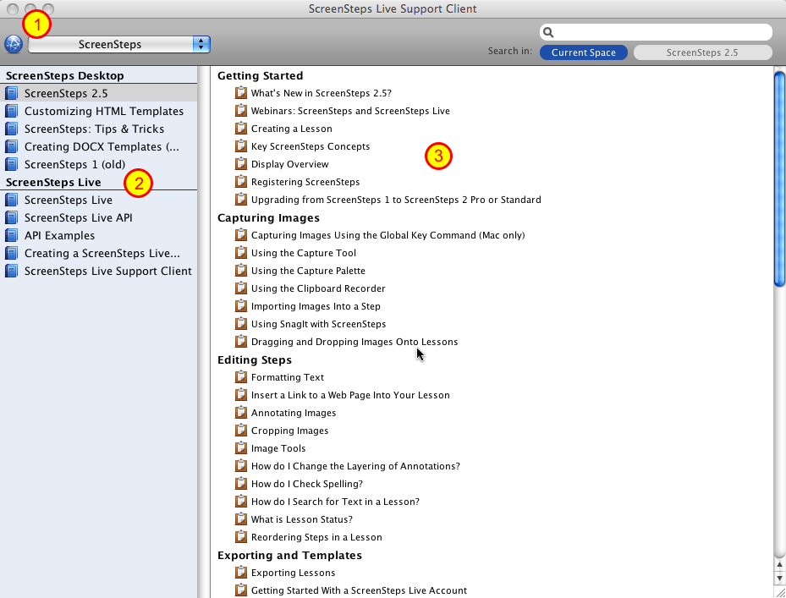
After clicking OK, content from your ScreenSteps Live account will load. The content you see is based on the content that the user whose credentials you entered has access to on ScreenSteps Live.

Spaces (1) appear in the upper-left corner of the window. Buckets and Manuals (2) in the selected Space appear in the left column and Lessons and Chapters (3) appear in the right column.

How Do I Preview a Lesson?

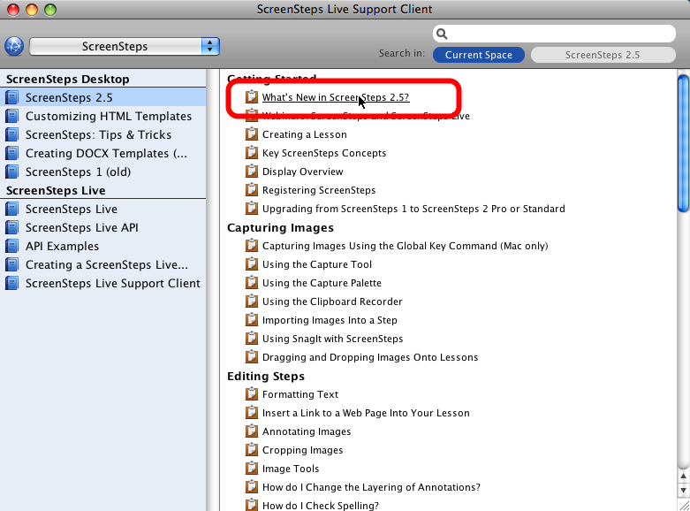
To load a lesson in your browser click on the lesson title. This will open the lesson within the content of the selected bucket or manual.

How Do I Copy a Lesson URL to the Clipboard?

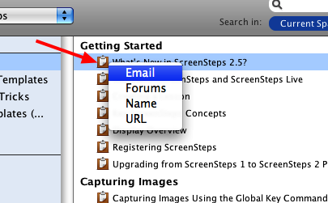
To copy a lesson url to the clipboard click on the clipboard icon that appears to the left of each lesson name. Clicking on this icon will display a menu of the available templates. Select a template to populate the system clipboard.

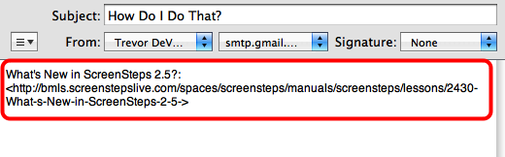
You can now paste the clipboard contents into the desired destination. In this example I have pasted the lesson name and url into an email.

Searching

How Can I Limit a Search To A Manual Or Bucket?

Searching a Space
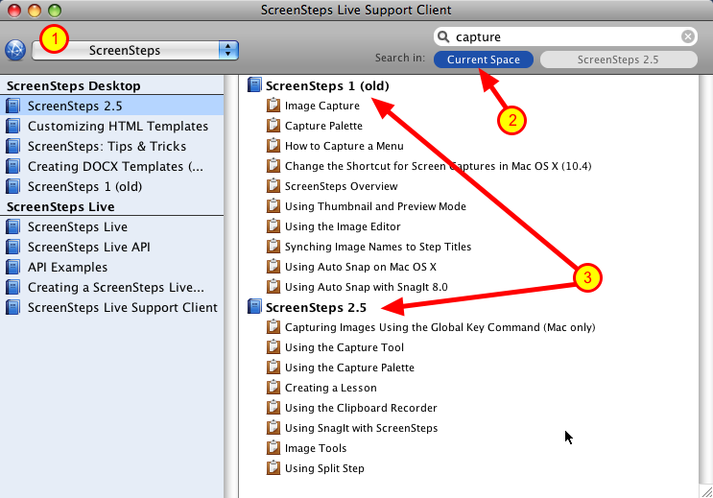
By default all searches will occur within the selected space (1) because the Current Space filter is selected (2).

When searching a space lessons are returned organized by into buckets and manuals (3).

Searching Selected Bucket/Manual
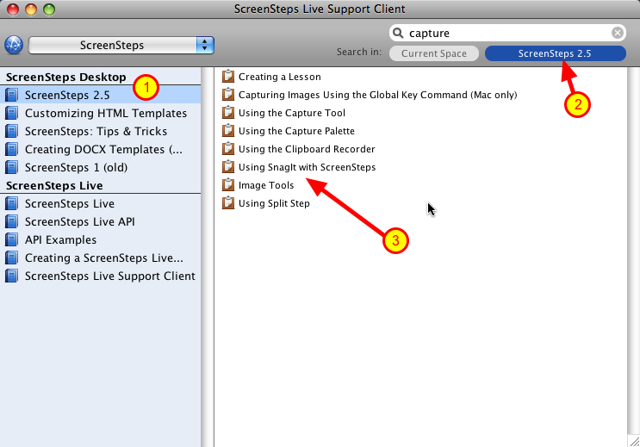
To search the selected bucket or manual (1) click on the bucket/manual filter (2). This filter always has the name of the selected bucket or manual displayed.

When searching a bucket or manual only lessons in that bucket or manual are returned (3).

Clipboard Templates

What Is A Clipboard Template?

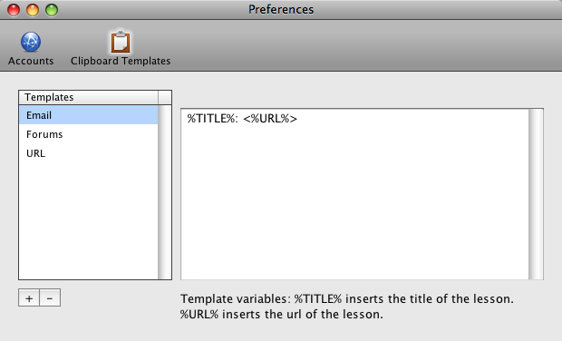
A clipboard template is used to format a lesson title and url for placement on the clipboard. Three templates are installed by default: Email, Forums and URL.

How Do I Customize or Add a Clipboard Template?

Customizing a Template
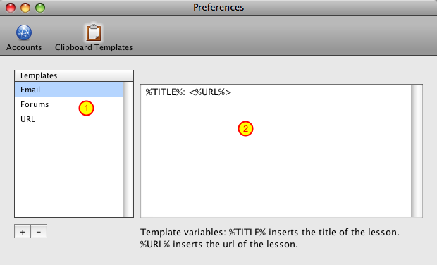
To customize a template begin by selecting it in the Templates column (1). Then enter any text you would like in the template contents field (2). Use the placeholder %TITLE% where you would like to have the lesson title appear. Use %URL% where you would like the lesson url to appear. You do not need to include both placeholders.

Add a Template
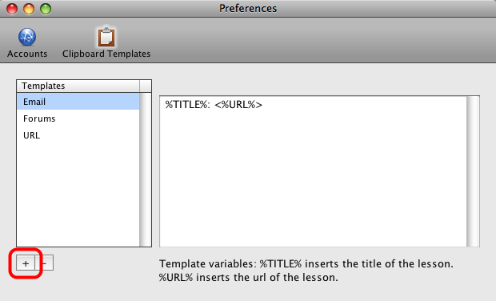
To add a template click the + button.

Adding Login Credentials to a Clipboard Template

This lesson will show you how to embed login credentials in your ScreenSteps Live Support Client urls. Users who click on these urls will automatically be logged in to your ScreenSteps Live account. It is advised that you only embed Reader logins into urls that you send out to users.

Open Preferences
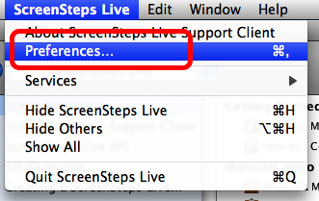

Create a Template
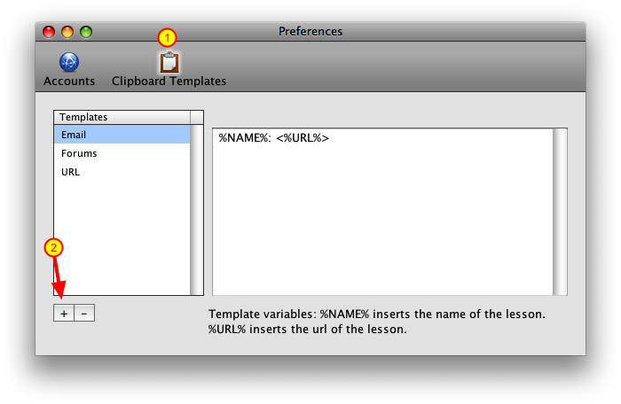
Select Clipboard Template (1) and select New Template (2)

Title Template
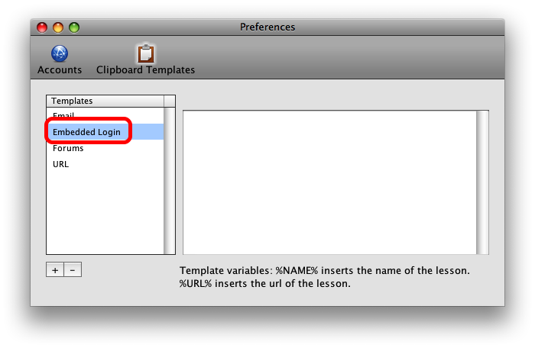

Enter Template Text
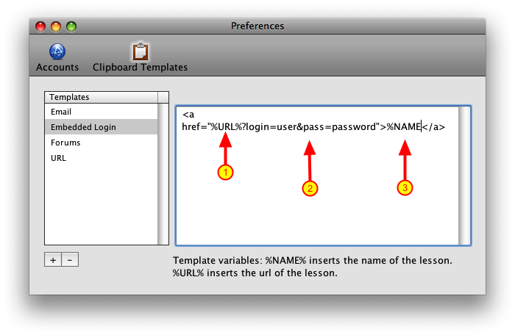
Setup an a href that tacks the login and password onto the end. You can use the text below and just replace the login and password:

<a href="%URL%?login=user&pass=password">%NAME</a>

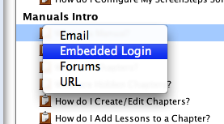
Now just select your template and you will have a url with an embedded login.

